The Lost Empire

Version 3.0

**April 15, 2013**

Group 10 - Daniel, Yue Ben, Nianzu Ma

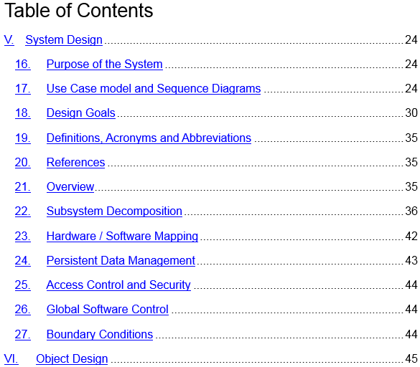

Table of Contents

V. System Design 24

16. Purpose of the System 24

17. Use Case model and Sequence Diagrams 24

18. Design Goals 30

19. Definitions, Acronyms and Abbreviations 35

20. References 35

21. Overview 35

22. Subsystem Decomposition 36

23. Hardware / Software Mapping 42

24. Persistent Data Management 43

25. Access Control and Security 44

26. Global Software Control 44

27. Boundary Conditions 44

VI. Object Design 45